Ninja Salvage

Synopsis:

This will be a story about a Ninja clan regaining its former glory and status before the Great Ninja War (Not Naruto) after many years of being wiped out.

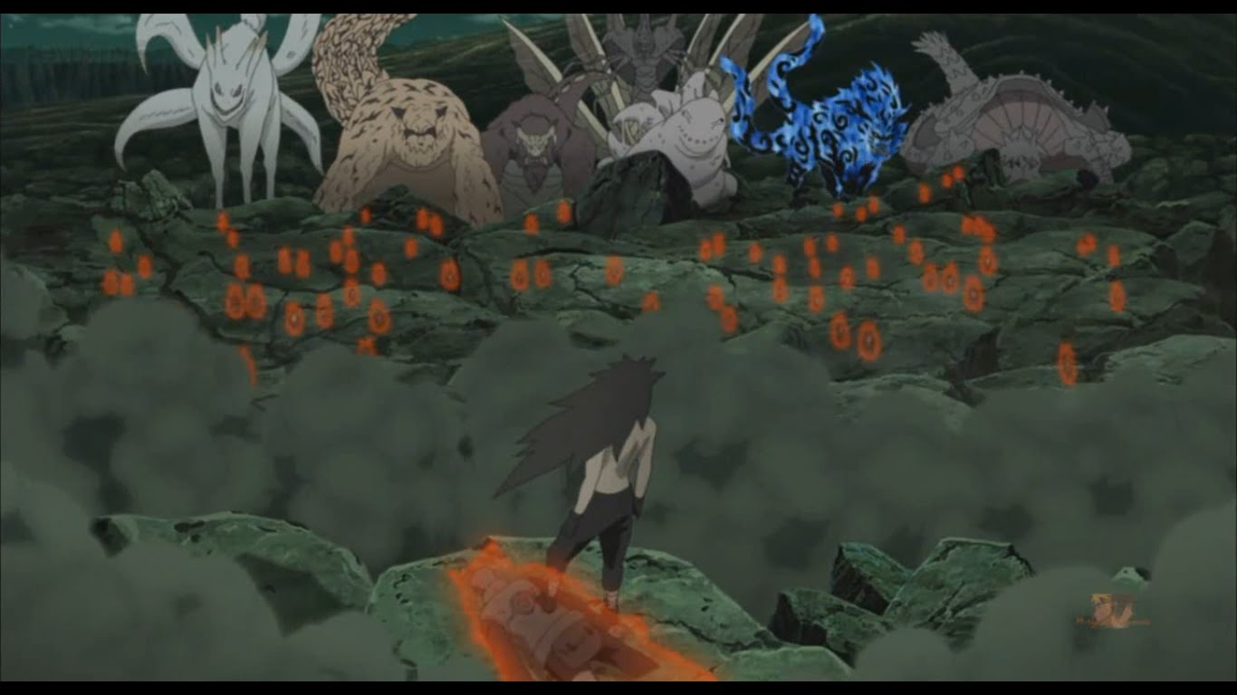

The existing clans have been at arguing with each other ever since the great War due to the loss of the leader clan. They debate and fight with each other to claim dominance in the region but to no avail. War will happen soon if a dominant clan does not take control. There are only 2 members left of the great leader ninja clan a wise sensei master, and a ninja apprentice. It is up to them to reform their lost alliances across the lands and reform the leader clan they lost all those years ago. The Ninja apprentice has remarkable abilities with his acrobatics but lacks offensive skills. He is still confident though that he can convince the other clans to support them again and stop an upcoming war. It will not be easy because simply picking one side to help will cause others to resist. Choosing sides will change the outcome of the story.